|  |  |  |
| --- | --- | --- |
|  |  |  |

GOVERNMENT OF INDIA



**MINISTRY OF SKILL DEVELOPMENT & ENTREPRENEURSHIP**

DIRECTORATE GENERAL OF TRAINING

**NATIONAL SKILL TRAINING INSTITUTE**

NSTI (W) Salt Lake,Kolkata-700091

**CERTIFICATE**

This is to certify that following trainees have completed their project titled

**“NSTI Smart Cloud Campus”**

**For IBM Program – IT, Networking and Cloud (Technical Diploma)**

|  |  |
| --- | --- |
| **ROLL NO** | **NAME** |
| ADIT19AU04163 | Shweta Roy |

|  |  |  |  |
| --- | --- | --- | --- |
| Ms. Arpita Roy | Mr. K. L. Kuli | Mr. G. C. Ramamurthy | Mr. Sarbojit Neogi |
| IBM Faculty | ADIT Director | Principal | Section-In-Charge |

# Creating Webpage by Using Node.js Application and Mongo DB

*Shweta Roy*

**INDEX**

|  |  |
| --- | --- |
| **Sr. No.** | **Table of Contents** |
| 1 | Introduction |
| 2 | Services and Tools Required |
| 3 | Project Architecture |
| 4 | Architecture Blocks Detail Working |
| 5 | Project Budget |
| 6 | Code |
| 7 | Conclusion |
| 8 | References |

**INTRODUCTION**

**Abstract**

**Introduction**

**Purpose**

**Modules**

**Scope**

**Abstract:**

This application is developed using NodeJS and the Express framework, when we want to interact with a MongoDB database from your code. Fortunately, this task is easy to accomplish using the Mongoose package for JavaScript. In this project I’ll show you how to create an application using NodeJS, Express and MongoDB.

**Introduction**

This was done to get us ready for whatever facet we chose. A major part of this project is to show what we have learned and put it into practice.

**Purpose**

The purpose of this document is to describe the functionality and specifications of the design of a web application and to learn how to build a simple web-based application using Node Js and Mongo DB.

**Modules**

* Home
* Overviews
* Updates
* Contact Us
* Login/Signup

**Scopes**

FEASIBILITY STUDY

After identifying the scope of the project, the feasibility study is needed to be carried out. It is basically keeping the following points in mind.

**Building the software for meeting the scope:**

The software has met the scope. As there is no data involved in the system, processing on the file, and the behavior of the project is already identified and bundled in quantitative manner. The processing of the software is very simple as it has been designed in php and it has been well divided into several functions according to the need.

**Technically feasible:**

The software is very much technically feasible. The software is very much concerned with specifying equipment and the software will successfully satisfy almost all the admin’s requirements.

The technical need for the system may vary considerably but might include:

a. The facility to produce output in a given time.

b. Response time under certain conditions.

c. Ability to process data at a particular speed. Therefore, the basic input/output of data is identified. So, the project can easily be built up and it will also be technically feasible.

**State of Art:**

The project is very much within the state of art since the project is a WINDOWS based; it uses very modern and common technique. Beside it is very much modern and user friendly. It also works as middleware i.e., only in between the user and the file. So, it is completely a state of art project.

**Financially Feasible:**

The project is very much financially feasible. The implementation and development cost of the software under the reach of any college.

Moreover, it requires some training for the use. So, training cost can be neglected and the resources of the software are very much available. It also reduces the labor and extra cost to be paid for labor. So indeed, it is financially feasible.

**Resources:**

As motioned earlier that the resources are easily available and the cost of training is almost negligible. Sometimes situations may arise when it may not be so much easy. For a person completely unaware of using a computer system could result in a training cost or for a very small organization the purchase of a computer, installment of the system and other charges may lead to a difficult matter.

**Services and Tools Required**

**Services Used**

**Tools and Software used**

**Services Used:**

Npm packages

**Available Technologies:**

Languages: HTML, CSS, JavaScript.

Runtime: - Node Js

Non-RDBMS: MongoDB

Library/Framework: Express, Mongoose, Bootstrap

**Tools Used:**

Editor Used: Visual Studio Code

Operating System: Windows 10

Browser: - Chrome

Documentation: - MS Word

**Hardware Used:**

Processor: Intel core i3

RAM: 4GB

Hard Disk: 1TB

**PROJECT ARCHITECTURE**

**Architecture**

**USER FRONTEND BACKEND**

|  |  |  |
| --- | --- | --- |
| **User Internet** | **Web designHTML 5** | Node.js JavaScript npm Computer Icons Web application, text, logo png |  PNGEgg**NODEJS 14.0**  Cloudant - Crunchbase Company Profile &amp; Funding**Database** |

**Architecture Blocks Detail Working**

|  |  |
| --- | --- |
|  |  |

**DFD (Data Flow Diagram)**

Web Application

DATABASE

**Entity Relationship Diagram**

*Sign-up*

**About Project**

###### Download Node Js application for windows and installing it. After installing set the path in system environmental variable. Go to command prompt and check that it is installed perfectly or not by using the command node -v.

Create an Html file with CSS, another Html files, Images, Java script files and save that file as index.html.

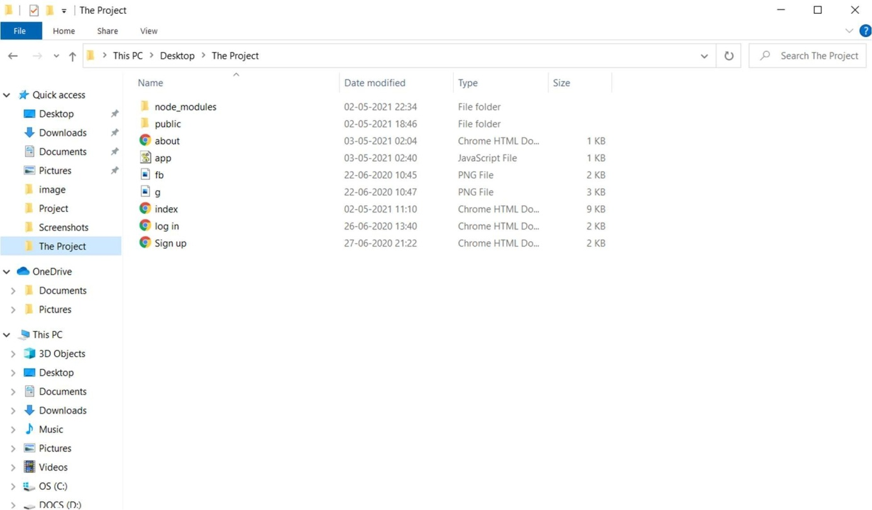

All HTMLs are saved in a folder, all images are saved in a folder image, and the CSS file also saved in a folder and all folders are in a folder.

Run index.html locally in a browser without joining any server. Check all files are working perfectly or not.

Installing express in command prompt with the command npm install express [npm= node package manager].

When it is installed you can find node modules and two json file automatically downloaded in your system.

Creating Server by using node js :

1. Write the proper code and save it with the extension *filename*.js and save itapp.js.
2. Check the code is running on local server properly. So, go to the terminal/command prompt browser and wrote localhost:(port number which you given on the code) and click theenter.

##### Existing Solution

1.Its manual process for earlier system.

2.Its more time consume for allprocess.

3.Need for moreresources.

**Screenshots of this application**

HOME PAGE:

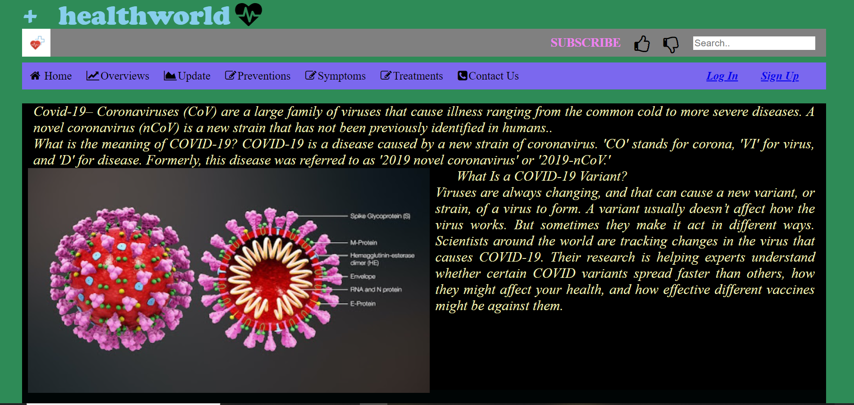

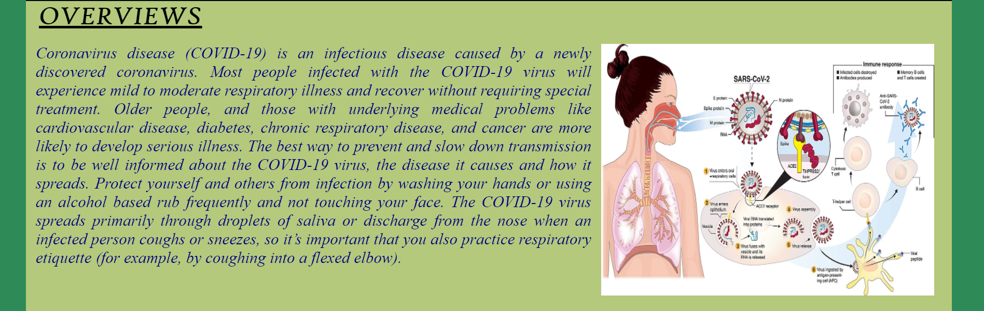



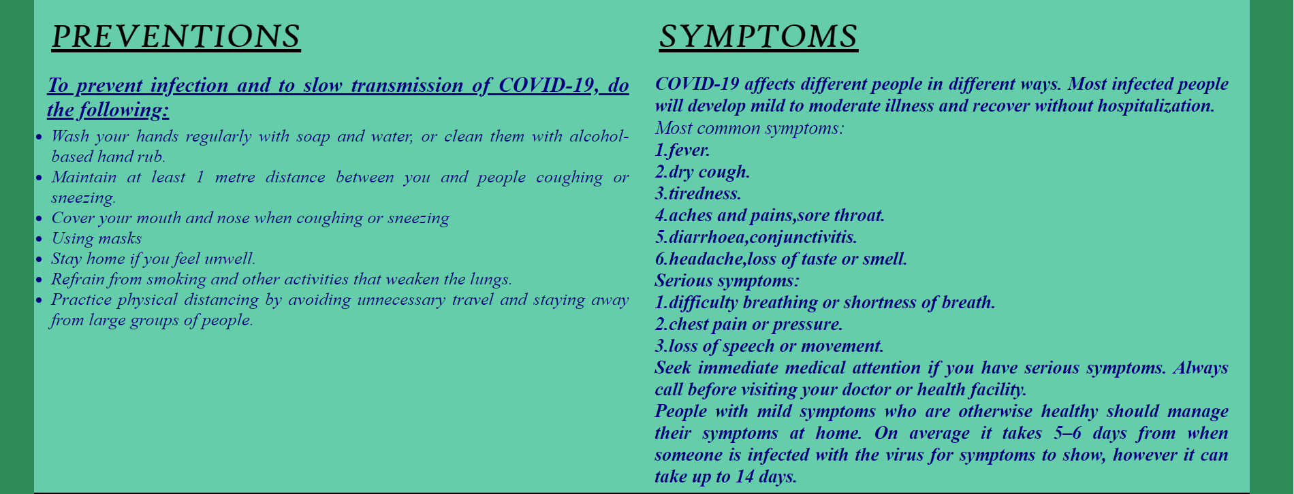

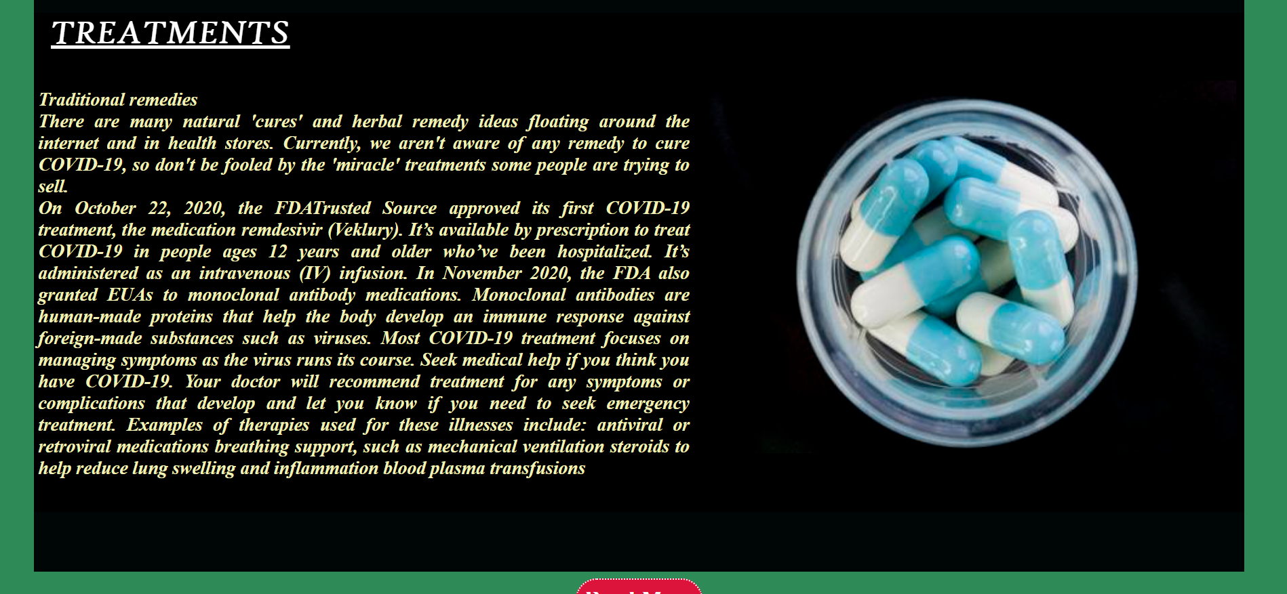



**Log in**

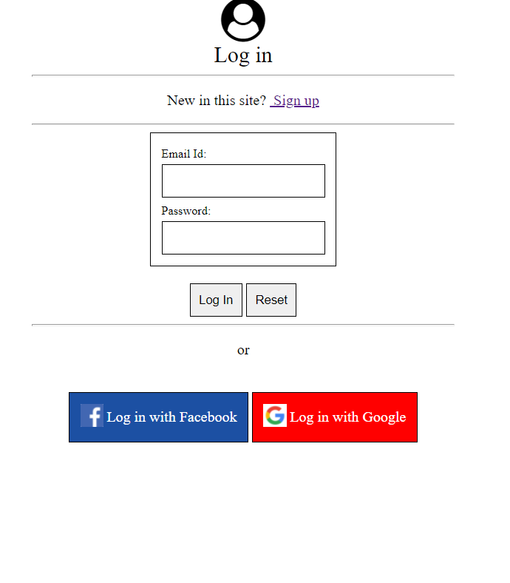

**Sign Up**

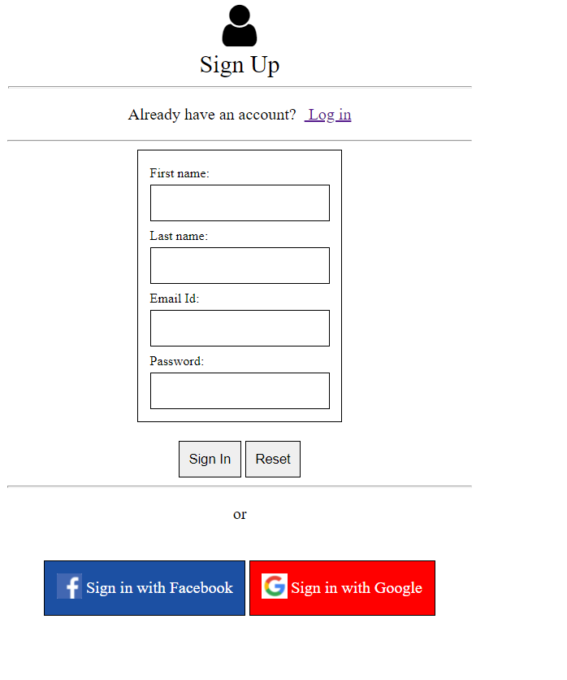

**About**



**SOURCE CODE**

index.html

<!DOCTYPE html>

<html>

    <head>

        <link rel="stylesheet" href="only.css">

        <title>Corona Virus</title>

        <meta name="viewport" content="width=device-width, initial-scale=1">

        <link rel="stylesheet" href="https://cdnjs.cloudflare.com/ajax/libs/font-awesome/4.7.0/css/font-awesome.min.css">

    </head>

    <body>

        <div class="header">

            <div class="one">

                <p style="font-family:Cooper Black"><b><font size="20px"  color="skyblue"> + &nbsp healthworld</font> &nbsp<i class="fa fa-heartbeat fa-3x " aria-hidden="true">

                </i></b></p>

            </div>

            <div class="three">

                <img src="image/image3.png"> </img>

                <p align="left">

                    <ul><li>

                        <input type="text" placeholder="Search..">

                    </li>

                    <li><i class="fa fa-thumbs-o-down fa-2x " aria-hidden="true">

                    </i> </li>

                    <li><i class="fa fa-thumbs-o-up fa-2x" aria-hidden="true">

                    </i> </li>

                    <li><a href="#"><fontcolor="violet"><B>SUBSCRIBE</B></font></a>

                </li>

            </ul></p>

        </div>

        <div class="two">

            <aside>

                <table class="h" cellpadding="15px">

                    <tr>

                        <td><a href="log in.html">Log In</a></td>

                        <td><a href="Sign up.html">Sign Up</a></td>

                    </tr>

                </table>

            </aside>

            <div class="menu">

                <ul>

                    <li><a href="#"><i class="fa fa-home " aria-hidden="true">

                    </i> Home</a>

                    <div class="sub1">

                        <ul>

                            <li><a href="#">Definition</a></li>

                            <li><a href="#">Types</a></li>

                        </ul>

                    </div>

                </li>

                <li><a href="#Overviews"><i class="fa fa-line-chart " aria-hidden="true">

                </i>Overviews</a></li>

                <li><a href="#Update"><i class="fa fa-area-chart " aria-hidden="true">

                </i>Update</a></li>

                <li><a href="#Preventions"><i class="fa fa-edit " aria-hidden="true">

                </i>Preventions</a></li>

                <li><a href="#Symptoms"><i class="fa fa-edit " aria-hidden="true">

                </i>Symptoms</a>

                </li>

            </li><li><a href="#Treatments"><i class="fa fa-edit " aria-hidden="true">

        </i>Treatments</a></li>

        <li><a href="#"><i class="fa fa-phone-square " aria-hidden="true">

        </i>Contact Us</a>

        <div class="sub1">

            <ul>

                <li><a href="#">Email: -

                ncov2019@gmail.com</a>

            </li>

            <li><a href="#">TollFree:1075</a></li>

            <li><a href="#">Helpline: -

            91-11-23978046</a></li></ul></div></li></ul></div>

        </div>

    </div>

    <div class="a">

        <div class="aa">

            <p class="k">

                Covid-19– Coronaviruses (CoV) are a large family of viruses that cause illness ranging from the common cold to more severe diseases. A novel coronavirus (nCoV) is a new strain that has not been previously identified in humans.<br>

                What is the meaning of COVID-19?

               COVID-19 is a disease caused by a new strain of coronavirus. 'CO' stands for corona, 'VI' for virus, and 'D' for disease. Formerly, this disease was referred to as '2019 novel coronavirus' or '2019-nCoV.'<br>

            </p>

            <img src="image/covid-19.jpg"width=50% height="400px">

            </img>

            <p class="k">

                &nbsp &nbsp &nbsp

                What Is a COVID-19 Variant?<br>

                Viruses are always changing, and that can cause a new variant, or strain, of a virus to form. A variant usually doesn’t affect how the virus works. But sometimes they make it act in different ways.

               Scientists around the world are tracking changes in the virus that causes COVID-19. Their research is helping experts understand whether certain COVID variants spread faster than others, how they might affect your health, and how effective different vaccines might be against them.</p>

        </div>

        <div class="ac">

            <H1 id="Overviews">OVERVIEWS</H1>

            <p class="y">

                Coronavirus disease (COVID-19) is an infectious disease caused by a newly discovered coronavirus.

Most people infected with the COVID-19 virus will experience mild to moderate respiratory illness and recover without requiring special treatment.  Older people, and those with underlying medical problems like cardiovascular disease, diabetes, chronic respiratory disease, and cancer are more likely to develop serious illness.

The best way to prevent and slow down transmission is to be well informed about the COVID-19 virus, the disease it causes and how it spreads. Protect yourself and others from infection by washing your hands or using an alcohol-based rub frequently and not touching your face.

The COVID-19 virus spreads primarily through droplets of saliva or discharge from the nose when an infected person coughs or sneezes, so it’s important that you also practice respiratory etiquette (for example, by coughing into a flexed elbow).

            </p>

            <img src="image/image1.jpg"></img>

        </div>

        <div class="ab">

            <IMG id="Update"src="image/image2.jpg"width=45% height=470px></IMG>

            <table>

                <tr>

                    <td><H1><font color="White">UPDATES</font></H1></td></tr>

                    <tr><td>    <ul class="k">

                    <p>On 2nd May,2021, the situations are...<b>

                    <li>Confirmed:1,95,49,656</li>

                    <li>Active:33,43,910</li>

                    <li>Recovered:1,59,81,772</li>

                    <li>Deceased:2,15,523</li>

                    </p></td></tr></table>

            </div>

            <div class="ad">

                <div id="Preventions">

                    <H1 > PREVENTIONS</H1> <h2 class="y"><u>To prevent infection and to slow transmission of COVID-19, do the following:</u></h2></td>

                    <ul class="y">

                        <li>Wash your hands regularly with soap and water, or clean them with alcohol-based hand rub.</li>

                        <li>Maintain at least 1 metre distance between you and people coughing or sneezing.</li>

                        <li>Cover your mouth and nose when coughing or sneezing</li>

                        <li>Using masks</li>

                        <li>Stay home if you feel unwell.</li>

                        <li>Refrain from smoking and other activities that weaken the lungs.</li>

                        <li>Practice physical distancing by avoiding unnecessary travel and staying away from large groups of people.</li></ul></p>

                    </div>

                    <div id="Symptoms"class="n">

                        <H1 > SYMPTOMS</H1><p class="y"><B>COVID-19 affects different people in different ways. Most infected people will develop mild to moderate illness and recover without hospitalization.</B></p>

                            <p class="y">

Most common symptoms:<b><br>

1.fever.<br>

2.dry cough.<br>

3.tiredness.<br>

4.aches and pains,sore throat.<br>

5.diarrhoea,conjunctivitis.<br>

6.headache,loss of taste or smell.<br>

Serious symptoms:<b><br>

1.difficulty breathing or shortness of breath.<br>

2.chest pain or pressure.<br>

3.loss of speech or movement.<br>

Seek immediate medical attention if you have serious symptoms.  Always call before visiting your doctor or health facility.<br>

People with mild symptoms who are otherwise healthy should manage their symptoms at home. On average it takes 5–6 days from when someone is infected with the virus for symptoms to show, however it can take up to 14 days. </p></p></div>

                        </div>

                        <div class="af"><div  id="Treatments"></div>

                            <IMG src="image/med2.jpg"width=45% height=440px></IMG>

                            <H1  ><font color="White"> TREATMENTS</font></H1>

                                &nbsp &nbsp &nbsp &nbsp &nbsp &nbsp<p class="k">

                                Traditional remedies<b><br>

There are many natural 'cures' and herbal remedy ideas floating around the internet and in health stores. Currently, we aren't aware of any remedy to cure COVID-19, so don't be fooled by the 'miracle' treatments some people are trying to sell.<br>

On October 22, 2020, <b>the FDATrusted Source approved its first COVID-19 treatment, the medication remdesivir (Veklury). It’s available by prescription to treat COVID-19 in people ages 12 years and older who’ve been hospitalized. It’s administered as an intravenous (IV) infusion.

In November 2020, the FDA also granted EUAs to monoclonal antibody medications.

Monoclonal antibodies are human-made proteins that help the body develop an immune response against foreign-made substances such as viruses.

Most COVID-19 treatment focuses on managing symptoms as the virus runs its course.

Seek medical help if you think you have COVID-19. Your doctor will recommend treatment for any symptoms or complications that develop and let you know if you need to seek emergency treatment.

Examples of therapies used for these illnesses include:

antiviral or retroviral medications

breathing support, such as mechanical ventilation

steroids to help reduce lung swelling and inflammation

blood plasma transfusions </p>

                        </div></div>

                    <div class="footer">

                        <center><br>

                    <a href="https://www.healthworld.com/directory/topics?ref=global">Read More</a><br><br>

                            <img src="image/fb2.png">

                            <img src="image/tt.png">

                            <img src="image/ig.png">

                        <br>

                        <br><a href=about.html>About us</a><br><br><hr width="20%"><br>

                     </center>

                    </div>

                </body>

            </html>

CSS

   *

        {

        padding:0px;

        margin:0px;

        box-sizing:border-box;

        }

        body

        {

        width:94%;

        height:auto;

        /*background-position:center;*/

        /*background-image:linear-gradient(to top right,forestgreen,black,indigo) ;*/

        /*margin:3%;*/

        background-color: #2E8B57;

        margin: 2px 40px 2px 40px;

        }

        .header

        {

        width:100%;

        height:170px;

        }

        .header .one

        {

        width:100%;

        height:52px;

        /*margin:10px 0px 10px 0px;*/

        }

        .header .three

        {

        width:100%;

        height:50px;

        /*background-image:linear-gradient(to bottom right, pink,grey);*/

        /*margin:10px 0px 10px 0px;*/

        background-color: #808080;

        }

        .three li

        {

        margin:5px ;

        padding:7px;

        float: right;

        }

        .three ul

        {

        /*margin:0px 0px 0px 40px;*/

        list-style:none;

        margin: 0px 5px 0px 40px;

        }

        .three a

        {

        text-decoration: none;

        font-size: 22px;

        }

        .three input[type=text]

        {

        float: right;

        padding: 2px;

        margin: 2px;

        border: none;

        font-size: 17px;

        }

        .three img

        {

        width: 50px;

        height: 50px;

        float: left;

        display: inline-flex;

        }

        .three ul li:hover

        {

        background: #DE33FF;

        padding:5px 10px 5px 10px;

        border-radius:15px;

        }

        .header .two

        {

        width:100%;

        height:45px;

        background:#43b4e0;

        margin:10px 0px 10px 0px;

        }

        .n a

        {

        text-decoration:none;

        color: #C97C7C;

        margin:0px;

        font-size:15px;

        font-family:Andulus;

        padding:0px 2px 26px 2px;

        display:inline-block;

        }

        .header .n td:hover

        {

        background:#b4c6d1;

        }

        .header .h

        {

        width: 15%;

        float: right;

        font-style: italic;

        color:red;

        font-weight: bold;

        font-size:20px;

        line-height: 45px;

        }

        .header .h td:hover

        {

        background:pink;

        color:black;

        }

                .menu

                    {

                        /*background-image:linear-gradient(to bottom left,Chartreuse,#f5f10f);*/

                        /*text-align:center;*/

                        width:inherit;

                        height:48px;

                        background-color: mediumslateblue;

                    }

                .menu ul

                    {

                        list-style:none;

                        display:inline-flex;

                    }

                .menu ul li

                    {

                        margin:5px ;

                        padding:7px;

                            /*  float:left; */

                    }

                .menu a

                    {

                        text-decoration:none;

                        color:black;

                        font-family:andulus;

                        font-size:20px;

                    }

                .menu i

                {

                    margin: 2px;

                }

                .menu ul li:hover

                    {

                        background:lightgrey;

                        padding:5px 10px 5px 10px;

                        border-radius:15px;

                    }

                .sub1

                    {

                        display:none;

                    }

                .menu ul li:hover .sub1

                    {

                        display:block;

                        position:absolute;

                        background-image:linear-gradient(to bottom right,khaki,skyblue,pink);

                        margin-top:12px;

                        margin-left:-12px;

                    }

                .menu ul li:hover .sub1 ul

                    {

                        display:block;

                        margin:5px;

                    }

                .menu ul li:hover .sub1 ul li

                    {

                        width:110px;

                        padding:9px;

                        border-bottom:1px dotted #fff;

                        background:transparent;

                        text-align:left;

                        border-radius:0px;

                    }

                .menu ul li:hover

                    {

                        border-bottom:none;

                    }

                .menu ul li:hover .sub1 ul li a:hover

                    {

                        color:#f2072b;

                    }

                    /*.sub2

                    {

                        display:none;

                    }

                .hover-me:hover .sub2

                    {

                        position:absolute;

                        display:block;

                        margin-top:-40px;

                        margin-left:140px;

                        background:rgb(0,100,0);

                    }*/

        h1

        {

            margin:20px;

            font-family:  High Tower Text;

            font-size:40px;

            font-style: italic;

            text-decoration: underline;

        }

        .a

        {

        /*border:1px solid black;*/

        width:100%;

        height:2760px;

        background-color: rgb(0, 5, 5);

        }

        .k

        {

        margin:0px 20px 0px 20px;

        text-align: justify;

        font-style: italic;

        font-size:25px;

        color:#f2f1b8;

        background-color: None;

        }

        .y

        {

        margin:0px 15px 0px 15px;

        font-size: 25px;

        font-style: italic;

        font-family:Andulus;

        /*font-weight:bold;*/

        color:navy;

        }

        /*.x

        {

        margin: 1px;

        width: 100%;

        background: pink;

        }*/

        .a .aa

        {

        width:100%;

        height:510px;

        text-align: justify;

        background:black;

        margin: 15px 0px 30px 0px;

        }

        .aa b

        {

        text-decoration: none;

        color: white;text-transform: capitalize;

        }

        .aa img

        {

        display: inline-flex;

        margin:0px 10px 0px 10px;

        float: left;

        }

        .a .ab

        {

        width:100%;

        height:480px;

        text-align: justify;

        /*background-image:linear-gradient(to bottom right,grey);*/

        background-color: "grey";

        }

        .ab a

        {

        text-decoration: none;

        color: khaki;

        }

        .ab ul

        {

        float: right;

        font-size:22px;

        margin:5px 20px 0px 2px;

        }

        .ab img

        {

        margin:1px 0px 0px 20px;

        float: left;

        }

        .a .ac

        {

        width:100%;

        height:480px;

        text-align: justify;

        /*background-image:linear-gradient(to bottom right,khaki,khaki,pink,pink,teal,teal);*/

        /*margin:15px 0px 30px 0px;*/

        background-color: #B4C97C;

        }

        .ac p

        {

        width: 60%;

        float: left;

        }

        .ac img

        {

        display:inline-flex;

        width:36%;

        height:390px;

        }

        .ad

        {

        width: 100%;

        height: 580px;

        text-align: justify;

        /*background-image:linear-gradient(to top right,orange,khaki,white);*/

        /*margin: 30px 0px 30px 0px;*/

        background-color: mediumaquamarine;

        }

        .ad div

        {

        float: left;

        width: 50%;

        height: inherit;

        }

        .ad ul

        {

        font-size:21px;

        margin:5px 15px 0px 20px;

        }

        .ad p

        {

        font-size:22px;

        margin:1px 25px 0px 15px ;

        }

        .n

        {

        /*background-image:linear-gradient(to bottom right,white, pink, grey);*/

        background-color: mediumaquamarine;

        }

        .n a

        {

        text-decoration: none;

        font-size: 22px;

        }

        .af

        {

        width: 100%;

        height: 590px;

        text-align: justify;

        /*background-image:linear-gradient(to bottom left,black, black, black,olivedrab);*/

        background-color: black;

        }

        .af p

        {

        font-size:22px;

        margin:5px ;

        }

        .af img

        {

        float: right;

        margin:80px 10px 5px 2px ;

        }

        .footer

        {

        width: 100%;

        height: 215px;

        }

        .footer a

        {

       text-decoration: none;

        color: white;

        font-size:27px;

        padding:8px;

        border:2px dotted #fff;

        background: crimson;

        border-radius: 28px;

        }

        .footer img

        {

        width: 40px;

        height: 40px;

        margin:15px 4px 15px 4px;

        }

        .footer img:hover

        {

        background: grey;

        padding: 7px;

        border-bottom: 2px dotted #fff;

        }

@media only screen and (max-width: 1200px)

{

    *

    {

        font-size: 15px;

        text-align: justify;

        margin: 0%;

    }

    body

    {

        width: 100%;

        height: auto;

        margin: 0px;

    }

    img

    {

        width: 30%;

        height: 30%;

        float: left;

    }

    .k

    {

        font-size: 15px;

        text-align: justify;

    }

    .y

    {

        font-size: 15px;

text-align: justify;

    }

    .ac img

    {

        width: 30%;

        height: 30%;

        float: right;

    }

    .menu a

    {

        font-size: 2px;

    }

    .header .fa

    {

        display: none;

    }

    .header td a

    {

    font-size: 5px;

    }

    div

    {

        font-size: 15px;

        text-align: justify;

    }

    .n p

    {

        font-size: 15px;

        text-align: justify;

    }

    .af

    {

        width: 100%;

    }

    .af p

    {

        font-size: 15px;

        text-align: justify;

    }

    .footer a

    {

     font-size: 10px;

     float:left;

    }

    .footer img

    {

        width:3%;

        height: 3%;

    }

}

Log in.html

<!DOCTYPE html>

<html>

<head>

    <title>

        log in

    </title>

    <meta name="viewport" content="width=device-width, initial-scale=1">

<link rel="stylesheet" href="https://cdnjs.cloudflare.com/ajax/libs/font-awesome/4.7.0/css/font-awesome.min.css">

    <style>

        .a

        {

            padding: 9px;

            border: 1px solid black;

        }

    .b

    {

        text-decoration: none;

        color: white;

    }

    </style>

</head>

<body> <center>

<form>

        <div> <i class="fa fa-user-circle fa-3x" aria-hidden="true">

</i><br><legend> <font size="5px">Log in </font></legend>

<hr  width="30%">

</div><p> New in this site?&nbsp<a href="Sign up.html"> Sign up</a></p><hr width="30%">

<table class="a">

        <tr>

            <td>

                <font size="2px">

                Email Id:

            </font>

            </td></tr>

                <tr><td>

                    <input class="a"  type=text required autofocus>

                </td></tr>

            <tr>

<td><font size="2px"> Password:</font> </td></tr>

<tr><td> <input class="a"type="password" required autofocus> </td>

</tr></table><br>

<input class="a" type="submit" value="Log In" >

<input class="a" type="reset" value="Reset">

</form><hr width="30%">

 <p>or</p>

 <table>

    <tr>

        <td>

 <table class="a"bgcolor=#1c50a3>

    <tr>  <td>

 <img src="fb.png" height=25px> </img></td>&nbsp

 <td><a class="b"  href="https://www.facebook.com">Log in with Facebook </a></td>

</tr></table></td>

<td>

<table class="a"bgcolor="red">

<tr>

 <td>

 <img src="g.png" height=25px></img></td> &nbsp

 <td><a class="b" href="https://www.google.com">Log in with Google </a></td></tr></table></td></tr></table>

</center>

</body>

</html>

Sign up.html

<!DOCTYPE html>

<html>

<head>

    <title>

        Sign up

    </title>

    <meta name="viewport" content="width=device-width, initial-scale=1">

<link rel="stylesheet" href="https://cdnjs.cloudflare.com/ajax/libs/font-awesome/4.7.0/css/font-awesome.min.css">

    <style>

        .a

        {

            padding: 9px;

            border: 1px solid black;

        }

    .b

    {

        text-decoration: none;

        color: white;

    }

    </style>

</head>

<body>

<body> <center>

<form>

    <div> <i class="fa fa-user fa-3x" aria-hidden="true">

</i><br>

        <legend> <font size="5px">Sign Up </font><hr  width="30%"></legend><p> Already have an account?  &nbsp<a href="log in.html"> Log in</a></p><hr width="30%">

<table class="a">

    <tr>

            <td>

                <font size="2px">

                First name:

            </font>

            </td></tr>

            <tr><td>

                    <input class="a"  type=text required autofocus>

                </td></tr>

            <tr>

            <td>

                <font size="2px">

                Last name:

            </font>

            </td></tr>

            <tr><td>

                    <input class="a"  type=text required autofocus>

                </td></tr>

        <tr>

            <td>

                <font size="2px">

                Email Id:

            </font>

            </td></tr>

                <tr><td>

                    <input class="a"  type=text required autofocus>

                </td></tr>

            <tr>

<td><font size="2px"> Password:</font> </td></tr>

<tr><td> <input class="a"type="password" required autofocus> </td>

</tr></table><br>

<input class="a" type="submit" value="Sign In" >

<input class="a" type="reset" value="Reset">

</form><hr width="30%">

<p>or </p>

 <table>

    <tr>

        <td>

 <table class="a"bgcolor=#1c50a3>

    <tr>  <td>

 <img src="fb.png" height=25px> </img></td>&nbsp

 <td><a class="b"  href="https://www.facebook.com">Sign in with Facebook </a></td>

</tr></table></td>

<td>

<table class="a"bgcolor="red">

<tr>

 <td>

 <img src="g.png" height=25px></img></td> &nbsp

 <td><a class="b" href="https://www.google.com">Sign in with Google </a></td></tr></table></td></tr></table>

</center>

</body>

</html>

About.html

<!DOCTYPE html>

<html>

    <head>

        <title></title>

        <style>

            body

            {

                width:100%;

                height:auto;

                background-color: mediumseagreen;

                background-position: center;

            }

            p

            {

                width: 50%;

                font-size: 50px;

                color: white;

                font-family: candara;

            }

            b

            {

                color:blue;

            }

            .l

            {

                font-size: 70px;

                font-weight: bold;

            }

        </style>

    </head>

    <body><center>

        <p class="l"><i>

        Thank you</p><p> for watching my webpage. Here the source data is linked from <b>healthworld.com </b>and

        <b>google</b>.

    </i>

    </p></center>

    </body>

</html>

App.js

var app = express();

var path = require('path');

// viewed at http://localhost:8080

app.use("/public",express.static("Public"));

app.get('', function(req, res) {

    res.sendFile(path.join(__dirname + '/html/index.html'));

});

app.get('/about.html', function(req, res) {

    res.sendFile(path.join(__dirname + '/html/about.html'));

});

app.get('/login.html', function(req, res) {

    res.sendFile(path.join(__dirname + '/html/login.html'));

});

app.get('/Signup.html', function(req, res) {

    res.sendFile(path.join(__dirname + '/html/Signup.html'));

});

app.listen(8080);

package.json

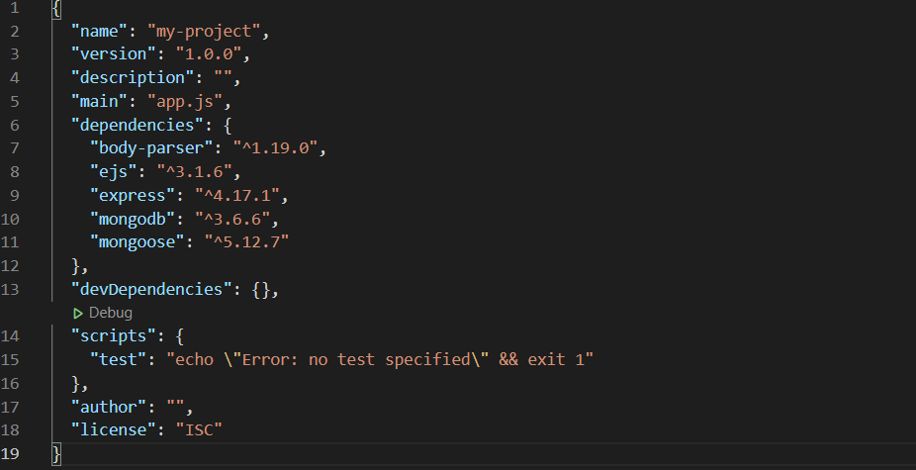

**CONCLUSION**

This project is a webpage. Here use node.js and mongo dB.Thecoronavirusdiseasecontinuestospreadacrosstheworldfollowinga trajectorythatisdifficulttopredict.Thehealth,humanitarianandsocio- economicpoliciesadoptedbycountrieswilldeterminethespeedandstrength of the recovery.

**REFERENCE**

* 1. https://covid19-indialive.easocare.com/
  2. [http://data.healthworld.in](http://data.healthworld.in/)
  3. www.youtube.in